SET-2

Regulations:
A18

H.T No

Sreenidhi Institute of Science and Technology
(An Autonomous Institution)
Code No: 7AC41 Date: 18-Dec-2019 (FN)

B.Tech II-Year I-Semester External Examination, Dec-2019/Jan-2020 (Regular)
BASIC ELECTRICAL ENGINEERING (IT)

Time: 3 Hours Max.Marks:70

Note: a) No additional answer sheets will be provided.
b) All sub-parts of a question must be answered at one place only, otherwise it will not be valued.
c) Missing data can be assumed suitably.

Part - A Max.Marks:20

Answer all QUESTIONS.

1. | Differentiate between ideal and practical transformers. | [2M]
2. | A 50Hz, 8-pole IM has full-load slip of 4%. The rotor resistance and standstill reactance are 0.01Ω and 0.1Ω per phase respectively. Find the ratio of maximum torque to full-load torque. | [2M]
3. | State superposition theorem. | [2M]
4. | Find the average value, r.m.s. value, form factor and peak factor for full wave rectified alternating current. | [2M]
5. | Give the applications of DC motors. | [2M]
6. | What is slip? | [2M]
7. | What is faraday’s law of electromagnetic induction? | [2M]
8. | List out the applications of PMMC instruments. | [2M]
9. | What are passive elements? | [2M]
10. | Draw the equivalent circuit of a transformer referred to primary. | [2M]

Part – B Max.Marks:50
ANSWER ANY FIVE QUESTIONS. EACH QUESTION CARRIES 10 MARKS.

11. | a) | Derive the EMF equation of a transformer. | [5M]
 | b) | Distinguish between the core type and shell type transformers. | [5M]
12. | a) | The power input to the rotor of a 440 V, 50 Hz, 3-phase, 6-pole induction motor is 60kW. It is observed that the rotor emf makes 90 complete cycles per minute. Calculate (i) the slip (ii) the rotor speed (iii) rotor copper loss and (iv) mechanical power developed. | [5M]
 | b) | Discuss about delta connection of three phase circuits. | [5M]
13. | a) | Explain the working principle of moving iron instruments. | [5M]
 | b) | A 230V, 50Hz single phase energy meter has a constant of 200 revolutions per kWh. While supplying a non-inductive load of 4.4 A at normal voltage, the meter takes 3 minutes for 10 revolutions. Find the percentage error of the instrument. | [5M]
14. | a) | Using superposition theorem, find the current in each branch of the network shown in Fig. below  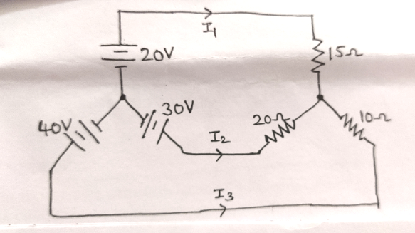 | [6M]
 | b) | Explain about series-parallel circuits. | [4M]
15. | a) | Explain about RL series circuits. | [5M]
 | b) | Describe the phasor representation of sinusoidal quantities. | [5M]
16. | a) | Discuss the principle of operation of DC generators. | [5M]
 | b) | Explain the types of DC motors. | [5M]
17. | a) | Explain about Kirchhoff’s laws. | [3M]
 | b) | Discuss about ac circuit containing capacitance. | [4M]
 | c) | Show the power stages in a DC motor. | [3M]
18. | a) | Describe constructional details of a transformer. | [4M]
 | b) | Write a short note on rotor emf. | [3M]
 | c) | Classify instruments. | [3M]

-- 00 -- 00 –

